CollabMind — Final-Year Project Audit
Sep 28, 2026 · @Dipendra Bhusal

Executive Summary
CollabMind is a genuinely ambitious idea — a private, multi-owner collaborative workspace where teams do grounded RAG chat and run autonomous study/research agents together — but the built system covers roughly a third of what the project documentation claims, and the third that exists has critical security holes that would let any caller impersonate any user or read any workspace's private data.
Four independent code audits (ai/, backend/, frontend/, plus docs/DB/infra) traced every claim in the Project Report and Synopsis against the actual source. The pattern that emerges is consistent: engineering discipline is real in places — parameterized SQL everywhere, transactional writes, a clean layered backend, strict TypeScript on the frontend — but the headline claims (row-level security, a 3-tier RBAC engine, 7 specialized agents, Y.js real-time co-editing, hybrid dense+BM25 retrieval, Casbin, Langfuse monitoring, audio/video overviews) are almost entirely undelivered. Only 1 of the 7 claimed agents exists, and even that one's properly agentic (tool-calling) implementation is dead code — the endpoint actually wired up runs a fixed, non-branching 5-step pipeline that also crashes on completion because it writes to a database column (agent_runs.finished_at) that was never created in the schema.
Three of the eight documents in docs/ also need attention before anything is submitted: LITERATURE REVIEW FINAL REPORT PPT.pptx is not about CollabMind at all — it's a literature review for an unrelated capstone ("SATYA", a government-scheme-eligibility system, different student team) that appears to have been misplaced into this folder — and both major_ppt.pptx files are unfilled CMRIT presentation templates with no CollabMind content.
Weighted completion estimate: ~33% of the documented scope (methodology in §6). Academic readiness: not yet defensible as-is — an evaluator who reads the Project Report and then opens the repository will find contradictions on nearly every major claim. This is fixable: the gap is well-scoped, the working ~33% is worth keeping, and §12 lays out three realistic paths (from a 2–3 week stabilization pass to a research-grade retrieval-evaluation contribution) to close it before a viva.

Project Understanding
(CMRIT, Dept. of AI & Data Science, course BAD685 — Synopsis and Project Report, both read in full.)
Problem, as stated: existing AI research/study tools (NotebookLM, ChatGPT, Notion AI) are single-user, don't ground answers in a shared private document set, offer no autonomous execution, and give teams no workspace-level privacy or governance — so collaborative research/study work either happens outside any AI tool or leaks context across an unmanaged single-owner account.
Proposed solution: "a private, multi-owner collaborative workspace powered by Google Gemini, where only members can interact with each other and with agentic AI" — grounded chat over uploaded sources, a "Studio" of generated study artifacts (flashcards, quizzes, guides, reports, and more), and 7 named autonomous agents (Research, Study Coach, Literature Review, Knowledge Organizer, Project Manager, Debate, Report Builder) that act with human-in-the-loop approval.
Intended users (per Synopsis): student groups, research teams, instructors, corporate analysts, legal/compliance teams — anyone who needs several people to reason over the same private document set without exposing it outside the group.
Documented architecture (6 layers): Presentation (Next.js) → API Gateway (REST + WebSocket, auth middleware, rate limiter) → Access Control (RBAC engine) → Knowledge Layer (ingestion/chunking/embeddings/vector DB) → AI Engine (Gemini RAG, citation mapper, contradiction detector) → Agent Layer (Gemini function-calling, planner/executor/memory/transparency log). §3 compares this to what is actually built.
Documented status: a 3-month, 4-person, 4-sprint plan (docs/collabmind_4sprints.html) — Sprint 1 auth+workspaces+chat+RAG, Sprint 2 ingestion breadth + contradiction detection + Y.js editing, Sprint 3 full Studio suite + security audit, Sprint 4 all 7 agents + production deployment + load testing. Git history and the repo's current state indicate the project is somewhere inside this plan, not at its end — the Studio suite and part of the RAG/chat core exist; most of Sprint 2's breadth, all of Sprint 3's security audit, and most of Sprint 4 (6 of 7 agents, deployment hardening, load testing) do not.
Core innovation, as claimed vs. as built: the differentiating claim is the combination of (a) private multi-owner workspaces, (b) grounded multi-document chat, and (c) autonomous agents acting on a team's behalf. (a) and (b) have real, working code behind them (with the security caveats in §7). (c) is the innovation the report leans on most heavily and is the least built — §9 examines whether the underlying idea is still a defensible contribution even at a smaller scope.

Technology Stack and Architecture
The documented 6-layer architecture (Presentation → API Gateway → Access Control → Knowledge Layer → AI Engine → Agent Layer) maps onto four real deployable services, but the "Access Control" layer the docs describe as a distinct RBAC engine doesn't exist as its own layer — it's a handful of ownership checks inside the Express backend, and the AI Engine sits entirely outside them.
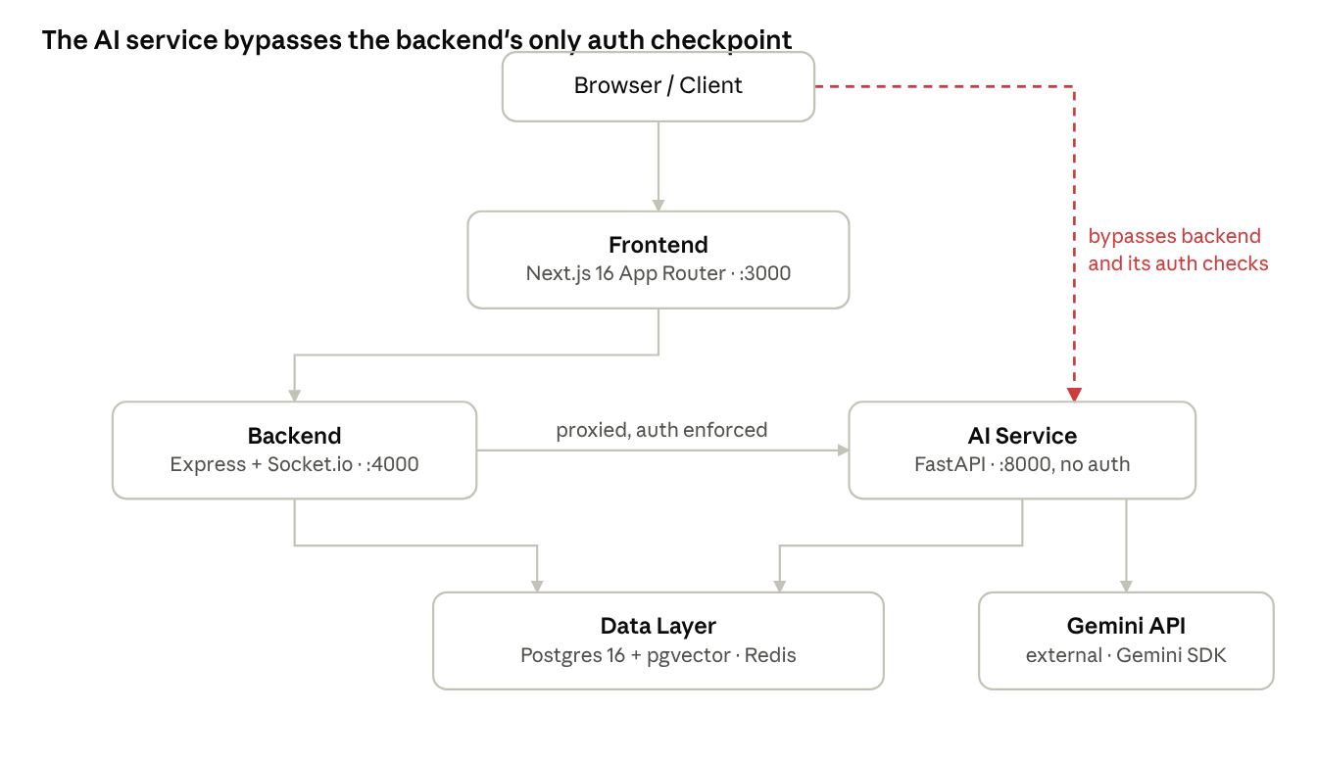
static architecture map, derived from code not docs
The dashed line is the finding that matters most: the AI service is published straight to the host (docker-compose.yml, 8000:8000) with no authentication or workspace-membership check of its own (detail in §7). The Express backend does correctly chain authenticate → requireWorkspaceMember → requireRole on its own routes — but that protection is entirely bypassable by anyone who reaches port 8000 directly: they can POST /chat with any workspace_id and read that workspace's indexed documents and chat history.
Layer | Documented | Actual
Frontend | Next.js, Tailwind, shadcn, NextAuth.js or Supabase Auth | Next.js 16 (App Router), React 19, Tailwind v4 + shadcn — both NextAuth v5 and Supabase Auth are wired in simultaneously; Supabase's session middleware is dead code, never called
Realtime / collab | Socket.io + Y.js (CRDT) | Socket.io only — no yjs/y-websocket dependency anywhere; no collaborative document editing exists
Backend API | Node.js + FastAPI behind one gateway, Casbin RBAC, rate limiter | Express 4 is the API/socket gateway; FastAPI (Python) is a separate, unauthenticated AI microservice, not behind the gateway; no Casbin; no rate-limit middleware anywhere
Access control | RBAC engine, 3-tier Owner / Editor / Viewer | 2-tier owner / member only — no Editor or Viewer role in the schema, no enum or CHECK constraint on role
Knowledge layer | PyMuPDF (PDF), python-docx (DOCX), Whisper (audio/video), hybrid dense + BM25 retrieval | pypdf only for PDF; no DOCX or audio/video ingestion path; retrieval is dense-vector only, no keyword/BM25 layer
Data stores | PostgreSQL with row-level security + Redis + pgvector/Pinecone | Postgres 16 + pgvector extension (no dedicated vector DB) + Redis — no Row-Level Security anywhere in the schema, confirmed by grep across every migration
AI engine | Gemini 2.5 Pro, LangChain + LangGraph, contradiction detector, citation mapper | Gemini 1.5 Flash/Pro via the raw google-generativeai SDK for most calls; LangChain/LangGraph present but exercised by only one dead-end agent path (§5); no contradiction detector
Agent layer | 7 named agents, Gemini function-calling, planner/executor/memory, transparency log | 1 agent type (study_coach) exists; its real tool-calling implementation is built but never invoked — the endpoint that's actually wired up runs a fixed, non-branching 5-step pipeline instead
Observability | Langfuse, Cloud Logging | print() statements (AI service) and console.log/morgan (backend) only — no structured logging, no tracing, no error monitoring
Deployment | Vercel + Cloud Run | docker-compose.yml with 4 local-oriented services; the frontend's own Dockerfile runs next dev, not a production build

Complete Codebase and Documentation Audit
What was inspected, in full: every source file in ai/ (FastAPI service, RAG pipeline, agents), backend/ (Express API + Socket.io gateway), frontend/src/ (Next.js app), the SQL in migration.sql / seed.sql / supabase/migrations/, docker-compose.yml, both root and per-service .env.example files, start.sh, test.sh, and all eight files in docs/ (three .pptx, two .docx, one .pdf, one .html, extracted and read as text, not guessed from filenames).
What was explicitly excluded or could not be verified: node_modules/, .next/, and ai/.venv were not explored (irrelevant to authored code). Nothing was executed — the shipped .env for the AI service carries GEMINI_API_KEY=dummy_key_not_needed_for_testing_ui, so runtime behavior (whether the RAG pipeline actually answers well, whether sockets reconnect cleanly, whether the finished_at bug in §5 actually raises) is inferred from static reading, not observed, and is flagged as such everywhere it matters. No load, security-penetration, or user testing was performed.
Documentation vs. implementation — consistency: the Project Report and Synopsis are well-written and internally consistent with each other, and the Base Papers / Literature Review deck cite real, traceable papers relevant to the stated approach (RAG grounding, multi-agent orchestration, privacy-preserving retrieval). But the report's claims were not derived from or updated against the implementation — nearly every architectural claim in §3 and every completion claim in §5 traces back to the plan (the 4-sprint document), not the code. Two further problems, unrelated to accuracy, were found in docs/:
- LITERATURE REVIEW FINAL REPORT PPT.pptx belongs to a different project. Its content is a literature review for "SATYA: A Multilingual AI-Based System for Government Scheme Eligibility Assessment and Awareness in India," submitted by a different student team (Shivam Pajiyar, Rakesh Ranjan, Anishek Raut, Jitendra Kumar Gupta) under a different guide, same course code and submission date. This needs to be removed from docs/ and replaced with CollabMind's actual literature review before any submission — the correct content already exists in CollabMind AI.pptx.
- major_ppt.pptx and major_ppt (1).pptx are empty CMRIT templates. Both are the unfilled 11-slide scaffold ("TOPIC," "Presented BY, NAME, USN") with no CollabMind content — not usable as evidence of a prepared final presentation.

Feature-by-Feature Completion Matrix
Module | Documented requirement | Actual implementation | Status | Evidence
Auth — Google OAuth | Google sign-in issues a session | Fully implemented, real Google ID token verification | Complete | backend/src/controllers/authController.js, authService.js
Auth — Email sign-in | Authenticated sign-in by email | Accepts any {email, name} with zero verification, mints a valid 7-day JWT | Broken (security) | authController.js:33-44, authService.js:71-91
Auth — access control | RBAC-gated, no bypass | Hardcoded tokens (demo-*, test-token, mock-token-for-testing) authenticate as a fixed demo user, no credential check | Broken (critical) | backend/src/middleware/authenticate.js:19
Realtime socket auth | Only authenticated members join workspace rooms | Fails open: missing/invalid JWT silently assigned a demo identity instead of being rejected; no membership check before granting room access | Broken (critical) | backend/src/socket/index.js:30,48-57,65-110
Workspace CRUD | Create/read/update/delete, owner-gated | Fully implemented, transactional, role-gated | Complete | backend/src/services/workspaceService.js
Membership management | Add/remove/list members, owner-gated | Fully implemented with correct error handling | Complete | backend/src/services/memberService.js
Members / invite UI | Invite by email, change roles | UI-only stub — isOwner hardcoded true, Invite button and role selectors have no handlers | Missing | frontend/src/app/workspace/[id]/members/page.tsx:16
3-tier RBAC (Owner/Editor/Viewer) | Documented permission matrix, §6.2.2 of report | Schema supports only 2 free-text roles (owner/member), no enum/CHECK constraint | Missing | migration.sql (workspace_members.role)
Row-level security | "Queries cannot return data from other workspaces" (repeated claim) | No ENABLE ROW LEVEL SECURITY / CREATE POLICY anywhere in any migration | Missing | grep across migration.sql, supabase/migrations/
Source ingestion — file upload / URL | Upload files, add URLs, trigger processing | Implemented end-to-end; embedding failures are silently swallowed and status still flips to 'ready' | Partial | backend/src/services/sourceService.js, ai/rag/embedder.py:152-159
Source ingestion — formats | PDF (PyMuPDF), DOCX (python-docx), audio/video (Whisper) | PDF only, via pypdf (different library than claimed); no DOCX, no audio/video path | Partial | ai/requirements.txt, ai/rag/embedder.py
RAG — chunking | 512-token / 50-token overlap | Implemented as documented, but chunked with an OpenAI tokenizer (tiktoken cl100k_base) against a Gemini embedding model — boundaries are only approximate | Complete (with a defect) | ai/rag/embedder.py:12-13,62-77
RAG — embedding | Gemini text-embedding-004 | Real path exists, but falls back to a deterministic SHA-256 pseudo-vector (no semantic meaning) whenever the API key is missing/dummy — which is the project's own shipped .env state | Partial (degraded as configured) | ai/rag/embedder.py:80-97, ai/.env:3
RAG — retrieval | Hybrid dense + BM25 keyword search, workspace-isolated | Dense-vector cosine search only, correctly scoped by workspace_id; no keyword/BM25 layer | Partial | ai/rag/retriever.py:14-64
RAG — generation / citations | Grounded chat with citation mapping | Prompt-level grounding only (not verified/enforced); falls back to raw chunk text with no key when ungrounded | Partial | ai/rag/pipeline.py:20-84
Chat — frontend | Send/receive with clickable citations | Send/receive wired via socket; citations are fully dead code — no store setter ever populates them, so citation markers can never be clicked | Broken | frontend/src/lib/store.ts, ChatMessage.tsx:30,44
Studio — flashcards / quiz / guide / report | 4 of ~14 documented generation types | Implemented end-to-end (backend + frontend), with the same Gemini-key-fallback caveat as chat | Complete (narrow scope) | ai/rag/generator.py, frontend/src/app/workspace/[id]/studio/
Studio — mind maps, knowledge graphs, oral exam simulator, rubric generator, Audio/Video Overview, slide-deck (PPTX) export | Documented Studio catalog | None implemented — no matching endpoints, no python-pptx, no TTS/audio pipeline found anywhere | Missing | grep across ai/, backend/
Agents — Study Coach (tool-calling / ReAct) | Gemini function-calling agent with real tools | Fully built (create_react_agent, 3 bound tools) but never invoked — constructed at startup and never referenced again | Complete but unreachable (dead code) | ai/agents/base_agent.py, study_coach.py, ai/main.py:43
Agents — Study Coach (the path actually wired up) | — | A fixed, non-branching 5-node LangGraph pipeline (no tools, no conditional edges); its final persistence step writes to agent_runs.finished_at, a column that does not exist in the schema | Broken | ai/agents/study_coach_graph.py:199-207, migration.sql:68-77
Agents — Research, Literature Review, Knowledge Organizer, Project Manager, Debate, Report Builder | 6 further named agents | No files, no endpoints for any of them | Missing | ai/agents/ directory listing
Agent human-in-the-loop approval | Pause for human sign-off, resume | Implemented via a 600s Redis-polling loop; works for one run at a time, no LangGraph checkpointer, loses in-flight runs on restart | Partial | ai/agents/study_coach_graph.py:111-151
Real-time co-editing | Y.js / CRDT collaborative documents | Not implemented — no yjs/y-websocket dependency anywhere | Missing | frontend/package.json
Multi-tenant isolation (AI service) | Namespace isolation, structurally prevents cross-workspace queries | Retrieval SQL is workspace-scoped, but the AI service itself has no authentication, and its port is published directly to the host — tenant isolation depends entirely on a bypassable upstream proxy | Broken (critical) | ai/main.py (no auth anywhere), docker-compose.yml:39-40
Rate limiting | "API Gateway ... rate limiter" | Not implemented on any service | Missing | grep across backend/, ai/
Automated tests | Test coverage across services | Zero unit/integration tests in any of the three services; test.sh is an unassert­ed curl smoke script with a hardcoded token fallback | Missing | no test files found; test.sh read in full
Deployment | Vercel + Cloud Run, production-ready | docker-compose.yml covers local orchestration; frontend container runs the Next.js dev server, not a production build | Partial | frontend/Dockerfile:7

Completion Percentage and Calculation Method
Each documented capability in §5 was bucketed into one of eight categories and scored by evidence: Complete → 100%, Partial → 40–60% depending on how much of the documented behavior actually works, Broken → 10–20% (code exists but the path fails or is unreachable), Missing → 0%. Category scores are the evidence-weighted average of their line items, not a raw count — a category with one Complete item and three Missing items is not simply 25%; items are weighted by how central they are to that category's documented purpose.
Category | Weight | Why this weight
RAG / Knowledge Pipeline | 20% | The project's core technical claim — grounded retrieval is what everything else (chat, Studio, agents) depends on
Auth & Access Control | 15% | Gates every other feature; a broken gate undermines the whole system regardless of what's behind it
Workspace & Collaboration Core | 15% | The "multi-owner" differentiator the report leads with
Agentic AI Layer | 15% | The single most heavily marketed feature (7 named agents) in the report
Studio Generation Suite | 15% | Large documented surface area (~14 generation types), but downstream of RAG rather than foundational
Security & Multi-tenancy | 10% | Distinct from Auth — this is workspace-boundary enforcement (RLS, AI-service isolation) specifically
Docs & Deployment | 5% | Necessary but not differentiating
Testing & QA | 5% | Necessary but not differentiating
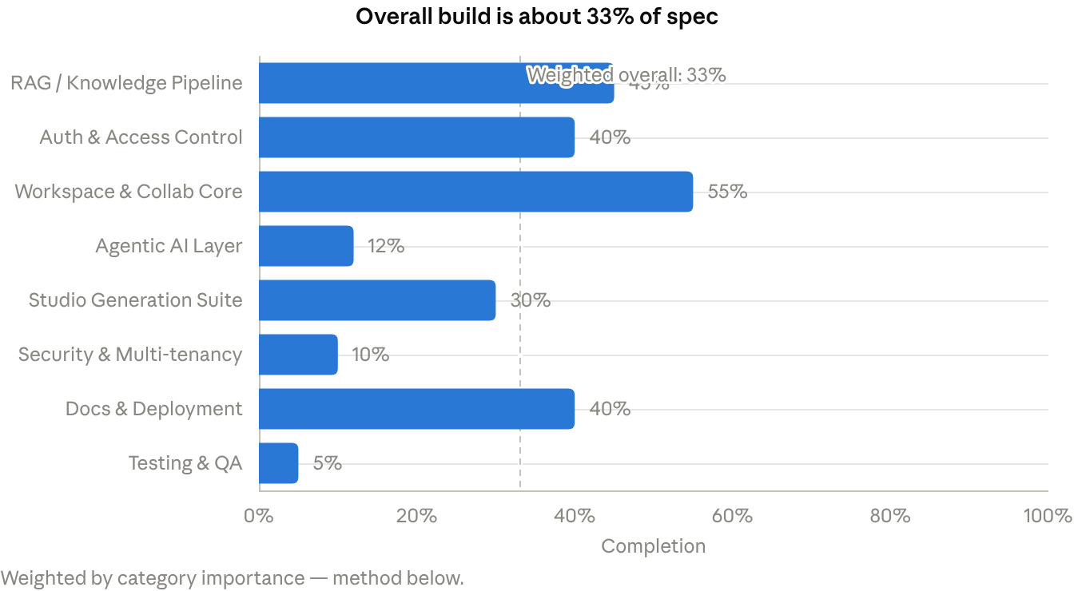
derived from §5's completion matrix, weighted per category
No category should be read as "nearly done" — even the highest, Workspace & Collaboration Core at 55%, is held back by a completely non-functional invite UI and the missing Y.js layer. The two categories that matter most for the report's own thesis — the Agentic AI Layer and Security & Multi-tenancy — are also the two furthest behind.

Code Quality, Security and Engineering Review
What's genuinely good. The backend is cleanly layered (routes/ → controllers/ → services/ → db/), controllers stay thin, and every one of the ~40 SQL call sites checked across backend/ and ai/ uses parameterized placeholders — no SQL injection was found anywhere. Multi-statement writes (createWorkspace, sendChatMessage) correctly use BEGIN/COMMIT/ROLLBACK with dedicated clients. The frontend runs TypeScript in strict mode and centralizes API calls through one helper with consistent error-class handling. The AI service's docstrings and the backend's JSDoc comments are above the typical capstone baseline. No TODO/FIXME markers were left anywhere in any of the three services — either genuinely finished-feeling code, or a team that doesn't use markers to track debt (worth noting either way, since §5 shows real unfinished paths with no markers at all).
Security — ranked by severity.
Severity | Finding | Where
Critical | Hardcoded auth-bypass tokens (demo-*, test-token, mock-token-for-testing) authenticate as a fixed user with zero credential check, in production code | backend/src/middleware/authenticate.js:19, socket/index.js:30
Critical | Socket auth fails open — a missing or invalid JWT is never rejected, only silently downgraded to the same demo identity | backend/src/socket/index.js:48-57
Critical | POST /api/auth/email mints a valid 7-day JWT for any {email, name} with no password, OTP, or ownership proof — full account takeover of any known email | backend/src/controllers/authController.js:33-44
Critical | Socket workspace:join_request grants membership and room access with no authorization check at all — any client can join any workspace by UUID | backend/src/socket/index.js:65-110
Critical | AI service has no authentication on any endpoint and its port is published directly to the host — tenant isolation depends entirely on a backend proxy that's trivially bypassed by calling port 8000 directly | ai/main.py, docker-compose.yml:39-40
High | No Row-Level Security anywhere in the schema, despite the Project Report repeatedly claiming it as the tenant-isolation mechanism | all .sql migrations
Medium | Wide-open CORS on both the Express app (cors() with no options) and Socket.io (origin: '*', comment says "adjust in production," never adjusted) | backend/index.js:28, socket/index.js:13-16
Medium | Hardcoded fallback JWT secret (super_secret_jwt_key_123) used both as a .env default and as a literal fallback in code if the env var is unset | authService.js:86, docker-compose.yml:70
Medium | No rate limiting anywhere — auth, chat, and upload endpoints are all unthrottled on all three services | global
Low | Broad except Exception handlers in the AI service return str(exc) directly to unauthenticated callers, which can leak internal error text | ai/main.py (multiple handlers)
Low | Frontend Dockerfile runs next dev, not a production build | frontend/Dockerfile:7
Correctness bugs worth fixing regardless of security. agent_runs.finished_at is written by two code paths but was never added to the schema — every agent run's completion write should raise UndefinedColumnError (inferred from the schema, not executed). embed_source's failure path still marks a source status='ready' even when zero chunks were stored, so failed ingestion is misreported as successful. The frontend's bearer-token retrieval reads localStorage.getItem('supabase_auth_token'), a key nothing in the codebase ever writes — the real NextAuth session token likely never reaches the backend on API calls, falling through to a hardcoded 'demo-guest-token' instead.
Duplication and dead code. Two full parallel Zustand store implementations exist in the frontend (src/lib/store.ts, live; src/store/*.ts, entirely unused, with conflicting type shapes) — clear evidence of an abandoned rewrite left in the tree. Supabase Auth's session middleware (lib/supabase/middleware.ts) is fully wired but never called. In ai/, a complete LangGraph ReAct tool-calling agent (base_agent.py, study_coach.py) is built and instantiated at startup and then never referenced again — the actual /agents/study-coach endpoint calls a separate, simpler, non-agentic implementation instead. A "check API key, try Gemini, fall back to X" pattern is repeated near-verbatim roughly nine times across ai/ with no shared helper.
Testing. No automated tests exist in any of the three services — no test files, no test framework in any package.json/requirements.txt, no test script. test.sh is a curl-based smoke script with no assertions on status codes or response shape, and it falls back to a hardcoded mock-token-for-testing if real auth fails rather than treating that as a failure.

Academic Evaluation and Scorecard
Scored as a Computer Science capstone, not as a commercial MVP — each dimension judged on demonstrated evidence from §5/§7, not on what the Project Report asserts.
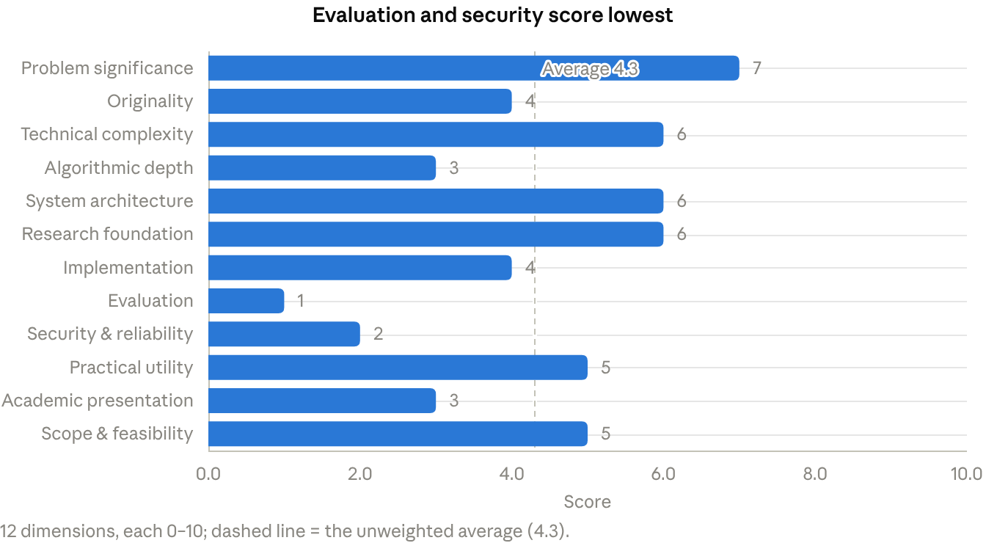
scored against the evidence in §5 and §7, not the report's claims
- Problem significance (7): clearly stated, appropriately scoped, real users named — the strongest section of the documentation.
- Originality (4): the multi-owner + agentic + grounded-chat combination is a reasonable synthesis, but the competitive-differentiation claims (vs. NotebookLM, Notion AI) are asserted, not demonstrated by anything the code does today (§9).
- Technical complexity (6): a 4-service system spanning RAG, realtime, and agent orchestration is objectively nontrivial to build, even though most of what exists uses standard SDK calls rather than custom algorithms.
- Algorithmic depth (3): no custom retrieval, reranking, or evaluation logic — the RAG path is essentially SDK calls with prompt-level constraints, not an algorithmic contribution.
- System architecture (6): the 4-service layout is a reasonable, mostly cleanly separated design; the score is capped by the AI service sitting entirely outside the one enforced trust boundary.
- Research foundation (6): the Base Papers document cites 10 real, relevant papers with genuine methodology comparisons — unusually solid for this stage — but almost none of the cited techniques (hybrid retrieval, multi-agent coordination, privacy-preserving RAG) made it into the implementation.
- Implementation (4): tracks the ~33% weighted completion in §6, discounted further for the critical bugs in §7.
- Evaluation (1): no automated tests, no benchmarks, no retrieval or generation metrics, no user study — test.sh is a manual smoke checklist, not evaluation.
- Security & reliability (2): five independently-critical findings in §7; as configured, any caller can impersonate any user or read any workspace's data.
- Practical utility (5): the use case is credible and the Studio features that do work are genuinely usable; not yet safe or reliable enough to hand to real users.
- Academic presentation (3): the Synopsis and Project Report are well-written, but the presentation deliverables are not ready — the literature-review file is for a different project and both presentation templates are empty (§4).
- Scope & feasibility (5): the original 3-month/4-sprint plan was ambitious for 4 people; with most of Sprints 2–4 still undone, the original scope is no longer feasible on the original schedule — §12 proposes three narrower, achievable alternatives.
This lands close to the 4/10 starting estimate, with the detail now attached: the drag isn't the idea, it's Evaluation and Security — the two dimensions a panel checks hardest and the two easiest to improve without touching the core concept.

Originality and Research-Gap Analysis
The project's own Base Papers and Literature Review documents already identify the relevant gaps well — the finding here is that most of those gaps are still open in this implementation too, not just in the market.
Existing approach | Limitations | CollabMind's current approach | Identified gap | Proposed contribution
NotebookLM | Single-user notebooks; no shared team workspace or role separation | Multi-owner workspace schema exists, but only 2 roles and no invite flow works | Team-scale private research space | Ship the invite flow + a real 3-tier role model — this alone is a legitimate, demonstrable differentiator once it works
Notion AI / ChatGPT "Projects" | Grounding is shallow or single-document; no per-workspace document isolation | pgvector retrieval is workspace-scoped at the SQL level, but the serving layer has no tenant auth (§7) | Grounded, genuinely isolated multi-document chat | Close the AI-service auth gap; isolation claims are only true once enforced end-to-end, not just at one SQL query
Generic single-agent RAG chatbots | No autonomous multi-step task execution, no human-in-the-loop gating | One agent type exists; its real tool-calling implementation (already built) is unreachable, and the reachable path is a fixed non-branching pipeline | Agentic, tool-using research assistants with approval gates | Wire up the existing base_agent.py/study_coach.py ReAct implementation instead of building new agents from scratch — the hardest part (tool-calling agent + approval gate) is already written and simply not connected
Standard dense-vector RAG (LangChain/LlamaIndex quickstarts) | Recall gaps on exact terms/names; no comparative evaluation of retrieval strategy | Dense-only retrieval, no BM25/hybrid layer, no retrieval metrics of any kind | The project's own literature review cites hybrid retrieval (ppRAG, MA-RAG) as relevant and better | Implement hybrid dense+keyword retrieval and measure it against the dense-only baseline — this is the one piece of the plan that is both unbuilt and a genuine, gradable research contribution (§12, §15)
What the project's own literature review flags as open problems in the field — lack of multi-agent coordination, no personalized learning loop, limited explainability, no standard RAG/agent evaluation metrics, weak trust/verification — describes CollabMind's current codebase about as accurately as it describes the competitors it was written to critique. That is not a criticism of the literature review (it is genuinely well-sourced); it is the clearest evidence that implementation has not yet caught up to the team's own stated understanding of the problem, which is a more defensible framing for a viva than claiming the gaps are closed.
Where real originality is achievable, not just claimed: the multi-owner-workspace framing is a legitimate, underserved niche (most competitors are single-user); the already-built-but-disconnected ReAct agent means "real" agentic behavior is closer than the completion numbers suggest; and a small, honest hybrid-vs-dense retrieval comparison would be a genuine (if modest) empirical contribution — something none of the cited competitor products publish for their own systems.

Critical Weaknesses and Missing Capabilities
Ranked by combined technical and academic impact.
- Four independent authentication bypasses in the backend. Hardcoded demo tokens, fail-open socket auth, an unverified email login, and an unauthorized socket workspace-join together mean the access-control layer is decorative — any one of the four lets an attacker impersonate any user. Fix: remove the hardcoded bypass entirely (gate it behind NODE_ENV==='test' at most, never ship it live), make socket auth reject on any failure, add real email verification (magic link or OTP), and check workspace_members before granting a socket room join.
- The AI service has no authentication and its port is published directly. This defeats the backend's access control entirely for anyone who can reach port 8000 — cross-tenant document and chat exposure. Fix: require the same JWT the backend issues on every AI-service call, and stop publishing port 8000 to the host in docker-compose.yml.
- The documentation overstates the implementation on nearly every headline claim — 6 of 7 agents, RLS, 3-tier RBAC, Casbin, Y.js, hybrid retrieval, Langfuse, and the full Studio catalog are all claimed and not built. Fix: this is an academic-integrity risk more than a technical one — rewrite the report's claims section to match §5 before any submission, or close the specific gaps that matter most (§12).
- Every agent run crashes on completion. agent_runs.finished_at is written by two code paths but was never added to the schema. Fix: one migration, ALTER TABLE agent_runs ADD COLUMN finished_at timestamptz; — the cheapest fix in this entire list.
- RAG runs on non-semantic fallback embeddings as configured. The shipped .env has a dummy Gemini key, so every embedding is a SHA-256 pseudo-vector with no semantic meaning — retrieval quality is effectively random in the project's own default state. Fix: document that a real key is required, and add a startup check that refuses to silently degrade (log a loud warning at minimum).
- Zero automated tests across all three services. No unit or integration tests exist anywhere; test.sh is an unasserted smoke script. Fix: §15 gives a concrete, scoped test plan — this is table stakes for a defensible capstone.
- The frontend's real session token likely never reaches the backend. apiCall() reads a localStorage key nothing ever writes, silently falling back to a hardcoded guest token; auth also silently degrades to a fake demo session whenever the backend is unreachable, which can mask real backend failures as normal empty-state UI. Fix: store the NextAuth token where api.ts actually reads it (or read it from the NextAuth session directly), and surface backend failures instead of masking them.
- Dead and duplicated code across every layer. A fully-built LangGraph ReAct agent, a complete Supabase Auth middleware path, and an entire second set of Zustand stores all exist unused — the ReAct agent especially is a wasted asset, since it's the hardest part of the "agentic" claim and already written. Fix: wire up the ReAct agent (it's most of the way to closing weakness #3's biggest gap); delete the rest.
- Two academic deliverables are not usable as submitted. The literature-review PPT belongs to an unrelated project; both presentation templates are empty. Fix: trivial to fix, but must happen before any submission — flagged here so it isn't missed under the larger technical findings.
- Two UI features are fully non-functional. The members/invite page has no event handlers at all, and chat citations can never render because nothing ever populates the store field they read from. Fix: both are small, contained frontend fixes relative to everything else on this list.

Proposed Enhancements and Prioritization
Enhancement | Why | Demonstrates | Complexity | How to measure | Priority
Remove the four auth bypasses (§10 #1) | Currently the single biggest reason the system is unsafe to run or demo | Secure-by-default engineering discipline | Low — mostly deletion + one real verification flow | Re-run test.sh with a real credential path; confirm bad tokens are rejected | Essential
Authenticate the AI service; stop publishing port 8000 | Closes the cross-tenant data exposure that undermines every privacy claim in the report | Understanding of trust boundaries in a multi-service system | Low — reuse the backend's existing JWT | Attempt a direct call to the AI service with no token; must be rejected | Essential
Add agent_runs.finished_at; fix the silent-failure status='ready' bug | Both are one-line-scale fixes with outsized correctness impact | Attention to data-integrity detail | Trivial | Run an agent to completion; confirm the row updates without error | Essential
Wire up the existing ReAct agent (base_agent.py) instead of the fixed pipeline | It's already built — this closes the biggest gap between claimed and real "agentic AI" for near-zero new code | Genuine tool-calling agent orchestration | Low — mostly routing, the hard part is done | Confirm the agent calls its tools (not just the LLM) on a multi-step prompt | Essential
Write a real test suite (auth, RBAC, workspace CRUD, RAG happy path) | Table stakes for any capstone claiming production-quality engineering | Testing discipline, regression safety | Medium | Coverage report; all four auth bypasses fail closed under test | Essential
True up the Project Report against §5 | Avoids a viva panel finding the same contradictions this audit found | Academic honesty and self-assessment | Low — writing, not code | Panel review / self-check against this matrix | Essential
Implement hybrid dense + keyword (BM25) retrieval, measured against the dense-only baseline | The one piece of the original plan that is both unbuilt and a real, gradable research contribution (§9) | Retrieval algorithm design, comparative evaluation | Medium | Precision@k and answer-groundedness rate, hybrid vs. dense-only, on a small curated QA set | Recommended
3-tier RBAC (Owner/Editor/Viewer) enforced in schema + middleware | Closes a specific, checkable documentation contradiction | Access-control modeling | Low–Medium | Attempt a Viewer-role write; must be rejected at both DB and API layers | Recommended
Basic rate limiting on auth and chat endpoints | Cheap hardening, directly addresses a documented-but-missing feature | Production-readiness awareness | Low | Load a few dozen rapid requests; confirm throttling kicks in | Recommended
Two more real agents (Literature Review, Report Builder) built on the now-wired ReAct pattern | Meaningfully narrows the "7 claimed, 1 built" gap without starting from zero | Multi-agent design, tool composition | Medium | Task-completion rate on a fixed set of sample prompts | Recommended
Y.js real-time co-editing | High documented ambition, but no current code to build on — a from-scratch feature | Distributed-systems / CRDT understanding | High | — | Optional
Audio/Video Overview, slide-deck (PPTX) export, oral exam simulator, mind maps | Large claimed surface area, but each is a new, unstarted subsystem with low marginal grading return relative to effort | Breadth of generation features | High (each) | — | Optional
The Essential row items are individually small (several are single-file or single-migration fixes); together they're what separates "has bugs" from "is currently unsafe to demo." The Recommended row is where real academic credit is won back cheaply by reusing what's already built rather than adding new scope.

Three Possible Project Scopes
 | Scope | Major deliverables | Est. effort | Key risk
1. Minimum viable academic project | Fix every Essential item in §11; nothing new added | All 4 auth bypasses closed · AI service authenticated · finished_at fixed · real test suite covering auth/RBAC/workspace/RAG happy paths · Project Report truthed-up to match §5 · the 2 misfiled/empty doc files replaced | 2–3 weeks, 1–2 people | Still scores low on Evaluation/Originality in §8 — defensible, not impressive
2. Advanced major project | Scenario 1 + reuse the existing ReAct agent for 2–3 real agents + hybrid retrieval + enforced 3-tier RBAC + basic rate limiting + CI running the test suite | Everything in Scenario 1, plus a genuinely multi-agent system built on code that already exists, and a measured retrieval improvement | 5–6 weeks, full team | Hybrid retrieval and multi-agent wiring both touch the RAG core — sequence them after Scenario 1's tests exist, so regressions are caught
3. Research-oriented capstone | Scenario 2 + a real comparative evaluation: dense-only vs. hybrid vs. reranked retrieval, measured on a small curated QA set built from the team's own study materials, reported with precision/recall/latency/cost | Everything in Scenario 2, plus a short written contribution framed as retrieval-strategy evaluation for private multi-tenant educational workspaces — publishable-adjacent, not claimed as publication-ready | 8–10 weeks, full team, contingent on remaining time before submission | The experiment only has evidentiary value if it's run on a real, working RAG pipeline — Scenario 1's fixes are a hard prerequisite, not parallel work
All three scenarios exclude Y.js co-editing, Audio/Video Overview, PPTX export, and the oral-exam simulator — each is a from-scratch subsystem with a large build cost and comparatively little marginal credit against the dimensions in §8 (see §17 for the explicit "don't build this" list). Which scenario fits depends on how much time remains before submission and how many people are actively working on it — that's the one input this audit doesn't have and would change the recommendation in §13.

Recommended Final Project Design
This assumes Scenario 2 (§12) — adjust down to Scenario 1 or up to Scenario 3 once the remaining timeline is known (see the comment on this doc).
- Refined title: "CollabMind: A Workspace-Isolated, Agentic RAG Platform for Collaborative Research and Study" — keeps the real differentiators (workspace isolation, agentic execution) and drops claims (Y.js, 7 agents) the final scope won't deliver.
- Refined problem statement: collaborative research and study currently forces a choice between single-user AI tools with no shared context, or generic document sharing with no grounded AI reasoning over it — CollabMind gives a team one private, access-controlled space where both grounded chat and autonomous task agents operate only within that team's own sources.
- Proposed solution (as actually deliverable): the 4-service architecture in §3, with the AI service brought inside the trust boundary, 2–3 real ReAct-based agents (built on the already-written tool-calling pattern), hybrid dense+keyword retrieval, and a 3-tier enforced RBAC model.
- Core features: workspace CRUD + working invite flow, grounded multi-document chat with real citations, flashcards/quiz/study-guide/report generation, 2–3 autonomous agents with human-in-the-loop approval.
- Advanced features: hybrid retrieval with a measured precision/groundedness comparison against the dense-only baseline; rate limiting; a CI pipeline running the new test suite on every change.
- Architecture: as diagrammed in §3, with the critical-path arrow (browser → AI service direct) removed — that arrow existing at all is the single diagram change that would mark this project as fixed.
- Major method / algorithm: hybrid retrieval (dense cosine + BM25 keyword) with score fusion — the one piece of the documented design that is both currently unbuilt and genuinely gradable as algorithmic work, rather than SDK integration.
- Research contribution: a small, honestly-scoped comparison of retrieval strategies (dense-only vs. hybrid) on a QA set built from the team's own study materials — not claimed as novel science, but a real measured result the team can defend under questioning.
- Evaluation methodology: §15.
- Expected deliverables: working system with §10's five critical issues closed, a passing test suite, a truthed-up Project Report, a corrected documentation folder, and the retrieval comparison write-up.
- Realistic timeline: 5–6 weeks of focused work per §12's Scenario 2 estimate, sequenced as §14 lays out — stabilize first, since every later phase (tests, new agents, evaluation) depends on the system not silently failing.

Technical Architecture and Implementation Roadmap
Each phase gates the next — don't start Completion work on a system whose auth is still bypassable, and don't run evaluation experiments before the pipeline they measure is trustworthy.
Phase | Tasks | Key files | Priority | Acceptance criteria
1. Stabilization | Remove the 4 auth bypasses; authenticate the AI service and stop publishing :8000; add agent_runs.finished_at; fix the silent-failure status='ready' bug; fix the frontend token-storage mismatch | middleware/authenticate.js, socket/index.js, ai/main.py, docker-compose.yml, one migration, ai/rag/embedder.py, frontend/src/lib/api.ts | Essential | test.sh run with a bad/missing token is rejected everywhere; an agent run completes without a DB error; a direct call to :8000 with no token is rejected
2. Completion | Wire up the existing ReAct agent in place of the fixed pipeline; build the members/invite UI against the API functions that already exist; connect the citations store field that nothing currently populates | ai/agents/runner.py, frontend/src/app/workspace/[id]/members/page.tsx, frontend/src/lib/store.ts | Essential | Agent responses show real tool calls, not just LLM text; inviting a member works end-to-end; a chat citation is clickable and opens the right source
3. Technical enhancement | Hybrid dense+BM25 retrieval; 3-tier RBAC enforced in schema + middleware; basic rate limiting; 1–2 more agents on the now-wired ReAct pattern | ai/rag/retriever.py, migration.sql, backend/src/middleware/, ai/agents/ | Recommended | Hybrid retrieval measurably outperforms dense-only on the eval set in Phase 4; a Viewer-role write is rejected at both DB and API
4. Research and evaluation | Build the small curated QA set; run the dense-only vs. hybrid comparison; record precision@k, groundedness, latency | new eval/ scripts, no production code changes | Recommended | A written comparison table with real numbers, not projected ones
5. Quality assurance | The test suite from §15; a manual security pass re-checking every item in §10; a load test on concurrent socket connections | new tests/ directories per service | Essential | CI green; the 4 fixed auth bypasses stay fixed under test (regression-proof)
6. Documentation | Rewrite the Project Report's claims section against §5; replace the misfiled literature-review file; fill in the presentation template; write a real root README.md (currently 2 lines) | docs/, root README.md | Essential | A reader of the report finds no contradiction with the repository
7. Presentation | Demo script covering the golden path (create workspace → upload source → chat with citation → run an agent → approve it) end-to-end on a real Gemini key; rehearse the viva questions in §16 | — | Essential | Demo runs without a fallback path silently masking a failure
Phases 1–2 are the floor for any submission regardless of which scenario in §12 is chosen; Phases 3–4 are what separates Scenario 2 from Scenario 1.

Testing and Experimental Evaluation Plan
None of the rows below have been run — this is a plan, not results. The security-verification rows are the closest to free (they check a yes/no fix), and should come first.
Test type | What to test | Baseline / comparison | Metric | Procedure
Security verification | The 4 backend auth bypasses + the AI-service auth gap | Pre-fix behavior (currently: all pass with a fake token) | Pass/fail per bypass | Send each documented bypass token/path after the Phase 1 fix; every one must be rejected
Unit — auth & RBAC | Role hierarchy (member < admin < owner), JWT verification, workspace-membership checks | — | Line/branch coverage on middleware/, services/authService.js | Standard unit tests (Jest) mocking the DB layer
Integration — workspace lifecycle | Create workspace → add member → upload source → send chat → run agent → approve → read result | — | End-to-end pass/fail on the golden path | Supertest against a real test Postgres/Redis (e.g. via docker-compose)
RAG retrieval quality | Dense-only vs. hybrid dense+BM25 | Dense-only (current implementation) | Precision@5, recall@5 | A curated 30–50 question set built from the team's own uploaded study materials, with hand-labeled relevant chunks
RAG groundedness | Whether generated answers only use retrieved context | A held-out set of questions with known answers not in the source set (should be refused/flagged) | % of answers that hallucinate outside the provided context | Manual review of a fixed sample (automatic groundedness scoring is optional/advanced)
Agent evaluation | Task-completion rate and tool-call correctness for the ReAct agent(s) | The current non-agentic fixed pipeline (as a baseline, once fixed) | % of prompts where the agent calls the correct tool with correct arguments | A fixed set of 15–20 representative prompts, scored manually
Load / concurrency | Concurrent Socket.io connections and chat throughput | — | Max concurrent sockets before latency degrades; message delivery rate | A simple scripted load generator (e.g. k6 or a Node script) against a local deployment
Resource consumption | AI service memory/latency under realistic chunk counts | — | p50/p95 latency for /chat and /embed | Time a fixed batch of requests against a workspace with ~100 chunks
Ablation studies (e.g. chunk size, overlap, reranking) are optional and only worth running if Scenario 3 (§12) is pursued — for Scenario 1 or 2, the retrieval-quality and groundedness rows above are sufficient evidence of a working, measured system.

Documentation and Viva Preparation
Deliverables checklist
Deliverable | Status
Title / abstract | Present (Synopsis)
Introduction / motivation | Present (Synopsis, Project Report)
Problem statement & objectives | Present, clear
Literature review | Present in CollabMind AI.pptx — but LITERATURE REVIEW FINAL REPORT PPT.pptx in the same folder belongs to a different project and must be removed/replaced before submission
Research gap | Present, and unusually well-sourced (§9)
Methodology / proposed system | Present in the Project Report
SRS | Not found as a standalone document
Architecture / UML diagrams | Architecture described in the Project Report; no dedicated UML (class/sequence) diagrams found
Database schema / ERD | Inferable from migration.sql; no dedicated ERD document
Implementation details | Root README.md is 2 lines — needs a real setup/architecture writeup
Testing methodology & results | Missing — no tests exist (§7, §15)
Comparative analysis | Present as a competitor feature table; not backed by measurement (§9 proposes closing this)
Limitations & ethical considerations | Not explicitly documented — should cover data privacy (given the current lack of RLS), hallucination risk, and API cost exposure
Conclusion & future work | Present in the Project Report
References | Present, real and traceable (Base Papers document)
User / installation manual | Missing — start.sh/test.sh exist as de facto scripts but aren't documented as a manual
Final presentation | Not ready — both major_ppt files are empty templates (§4)
Likely viva questions, with grounded answer outlines
- "Your report says you have row-level security. Show me the policy." — Answer honestly: RLS was planned (it's in the sprint plan) but not implemented; tenant isolation currently relies on application-layer WHERE workspace_id = $1 filtering, which §7/§10 show is bypassable at the AI service. State the fix plan from §14.
- "You claim 7 agents. How many actually run?" — One agent type exists; its real tool-calling implementation is built but unreachable, and the reachable path is a fixed pipeline. Explain why (§5, §10 #8) and what reusing it looks like (§11).
- "Walk me through what happens if GEMINI_API_KEY isn't set." — Describe the SHA-256 pseudo-vector fallback and the raw-chunk-text generation fallback (§5) — the system degrades silently rather than failing loudly, which is itself a finding worth stating.
- "How is a hardcoded test-token accepted in your auth middleware?" — Don't defend it; state it as a critical bug found during self-audit and describe the fix (§10 #1, §14 Phase 1).
- "What's your test coverage?" — Zero automated tests currently; explain the plan in §15 and, ideally, show it partially executed by viva time.
- "Why does your schema only have two roles when your report describes three?" — State the contradiction directly and the fix (§5, §11).
- "What's actually novel here versus NotebookLM or ChatGPT?" — Use §9's honest framing: multi-owner workspace isolation and (once wired up) real agentic tool use are the defensible differentiators; the broader feature list is not yet evidence of novelty.
- "How did you evaluate your RAG pipeline's retrieval quality?" — If Phase 4 (§14) was completed: present the dense-vs-hybrid numbers. If not: state plainly that no formal evaluation exists yet and describe the planned method (§15) rather than improvising a number.
- "This literature review PPT is about a completely different project." — Acknowledge it was a folder mix-up, point to the correct content in CollabMind AI.pptx, and confirm the misfiled document has been removed.

Final Verdict and Immediate Next Steps
- Worth continuing, or redesign the concept? Continue. The problem is real, the four-service architecture is a reasonable shape for it, and the parts that are built (auth's happy path, workspace CRUD, RAG's core pipeline, four Studio generators) show the team can execute. The gap is closing what's claimed, not rethinking what's wanted.
- Can the existing work be salvaged? Yes — §6's ~33% weighted completion includes genuinely solid pieces (parameterized SQL throughout, transactional writes, strict-TypeScript frontend, a working RAG happy path) that don't need rebuilding, only securing and finishing.
- Minimum necessary work before it's defensible? §12 Scenario 1: close the 5 critical/high security findings in §10, fix the finished_at and token-storage bugs, add a real test suite, and true up the Project Report against §5. Nothing on that list is conceptually hard — most of it is deletion, one migration, and honest documentation.
- Ambitious but still feasible? Reusing the already-built ReAct agent for 2–3 real agents, plus a measured hybrid-vs-dense retrieval comparison (§11, §12 Scenario 2–3). Both build on code or citations that already exist rather than starting new subsystems.
- What to implement first? §14 Phase 1 (Stabilization) — specifically the auth bypasses and the AI-service auth gap. They're fast to fix and everything else (tests, new features, evaluation) is untrustworthy to build on top of an insecure, silently-degrading foundation.
- What to explicitly exclude from the final scope? Y.js/CRDT co-editing, Audio/Video Overview, PPTX slide-deck export, the oral exam simulator, and the remaining 4–5 named agents beyond the 2–3 planned in Scenario 2 — each is a from-scratch subsystem whose build cost is high relative to its marginal credit against the §8 scorecard, and none of them are what a viva panel is likely to probe first.
Immediate next steps, in order: (1) pull LITERATURE REVIEW FINAL REPORT PPT.pptx out of docs/ today — it's a zero-effort fix with real submission risk; (2) fix the 4 backend auth bypasses and the AI-service auth gap; (3) add the missing finished_at column; (4) decide which scenario in §12 fits the remaining timeline (left as an open question in the comment on this doc); (5) start the test suite before adding any new feature, so every later change is regression-checked.

